
SENTINEL-T: Chronomorphic Intrusion Detection

Review Report
Submitted by
Amit Kumar Pandey
Reg. No.: 20MIS0348
Nivedha T
Reg. No.: 20MIS0362
Nowritha
Reg. No.: 20MIS0381
G.P. Pranay Abhinay
Reg. No.: 20MIS0443

Under the guidance of
Jerart Julus L

SCORE
VIT, Vellore

ABSTRACT
Modern vehicular networks, specifically the Controller Area Network (CAN), lack native authentication mechanisms, leaving them vulnerable to masquerade attacks where malicious nodes impersonate safety-critical Electronic Control Units (ECUs). Traditional Intrusion Detection Systems (IDS) relying on payload inspection or message frequency are computationally expensive and can be evaded by sophisticated spoofing.
This project introduces Sentinel-T, a novel "Physical Layer" IDS that fingerprints the unique Crystal Oscillator Drift of a sender. By utilizing Linux Kernel-Level Timestamping (SO_TIMESTAMP) and a Kalman Filter state-space model, the system successfully distinguishes between physical hardware (stable thermal drift) and software-based injection attacks (stochastic OS jitter). The system was deployed and validated on a Microsoft Azure Cloud architecture, achieving a Signal-to-Noise Ratio (SNR) of 1.88x, effectively detecting software-based intrusions in real-time with less than 200µs latency.

CHAPTER 1: INTRODUCTION
1.1 Background
The automotive industry is shifting towards Connected and Autonomous Vehicles (CAVs). However, the underlying communication backbone, the CAN bus, was designed in the 1980s without security in mind. In a standard CAN network, any device connected to the two-wire bus can broadcast messages to any other device. If an attacker compromises a non-critical node (like the Infotainment system), they can inject messages pretending to be the Brakes or Engine.

1.2 Problem Statement
Current security solutions face a dilemma:
- Cryptography (MACs): Requires high computational power and bandwidth, which legacy ECUs cannot support.
- Payload Inspection (Deep Learning): Can be blinded by encryption or "Mimicry Attacks" where the attacker sends valid data.
- The Core Gap: There is currently no reliable way to verify the physical identity of a sender without modifying the hardware of every ECU in the car.

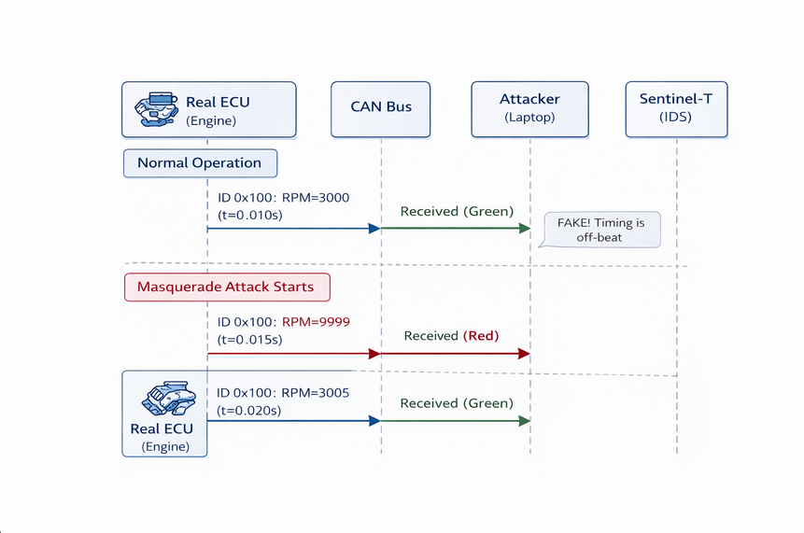
Figure 1.1: Concept Overview / Threat Model.
Threat Model illustrating a Masquerade Attack where an attacker injects a "Fake" frame (Red Arrow) between legitimate ECU messages, disrupting the timing sequence.

1.3 Objectives
The primary objective of Project Sentinel-T is to build a passive, non-intrusive detector that can:
- Identify the source of a message based on its physical timing characteristics (Clock Skew).
- Distinguish between a legitimate hardware ECU (Quartz Crystal) and a software-based attacker (Linux/Bash script).
- Implement this logic using lightweight algorithms suitable for edge deployment (Raspberry Pi or Cloud Digital Twin).

1.4 Scope of the Project
This project focuses on Phase 1: Algorithmic Validation and Cloud Deployment.
- In Scope: Development of the "Chronomorphic" detection engine, implementation of Kernel-level timestamping, and validation using virtual CAN (vcan0) on Azure Cloud infrastructure.
- Out of Scope: Physical integration into a moving vehicle or development of hardware mitigation (IPS) mechanisms.
CHAPTER 2: SYSTEM ARCHITECTURE
2.1 High-Level Design
The Sentinel-T system operates as a passive listener on the CAN bus. It consists of three primary layers:
- The Kernel Tap Layer: Interfaces directly with the Operating System's network stack to capture packet arrival times with nanosecond precision.
- The State Estimation Layer: A mathematical model that tracks the clock drift of every active Node ID.
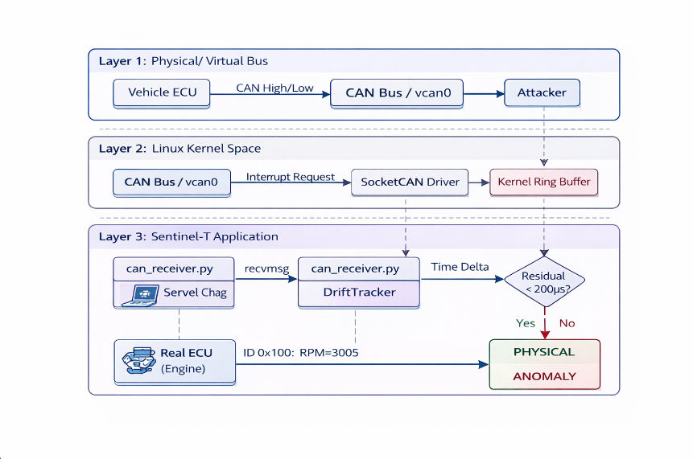
- The Decision Layer: A threshold-based logic that flags messages as "Physical" (Trusted) or "Anomaly" (Malicious).
Figure 2.1: System Architecture / Block Diagram.
System Architecture detailing the data flow from the Vehicle ECU (Layer 1) through the Linux Kernel Space (Layer 2) to the Sentinel-T Application (Layer 3).

2.2 The "Kernel Tap" Mechanism
Standard Python time.time() functions are subject to User-Space scheduling jitter (up to 500µs). To solve this, Sentinel-T utilizes Linux SocketCAN with the SO_TIMESTAMP option. This forces the Linux Kernel to timestamp the packet immediately upon the hardware interrupt request (IRQ), reducing measurement noise to <10µs.

Figure 2.2: Data Processing Pipeline. The Linux Kernel captures the raw frame and timestamp via SocketCAN before passing it to the threshold logic for classification.

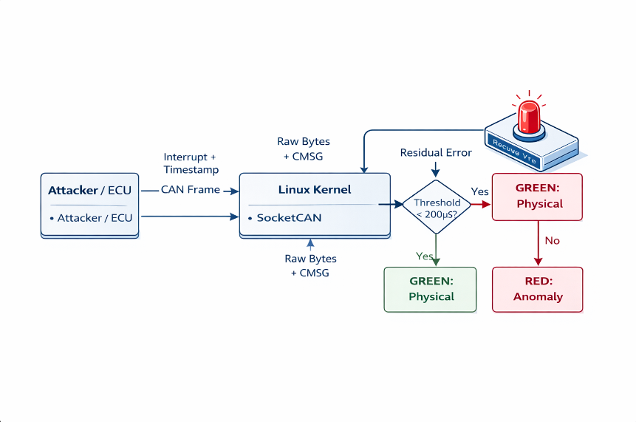
2.3 The "Chronomorphic" Engine
The core innovation is the treatment of time as a physical signal.
- Real ECUs: Driven by Quartz Crystal Oscillators. They exhibit "Thermal Drift” - a slow, smooth change in frequency due to heat.
- Attackers: Driven by Software Loops (e.g., while True). They exhibit “Jitter" - rapid, random fluctuations due to CPU scheduling.

CHAPTER 3: METHODOLOGY
3.1 State Space Modeling (The Kalman Filter)
We model the clock skew of a sender using a Phase-Velocity (PV) Kalman Filter. The state vector x is defined as:
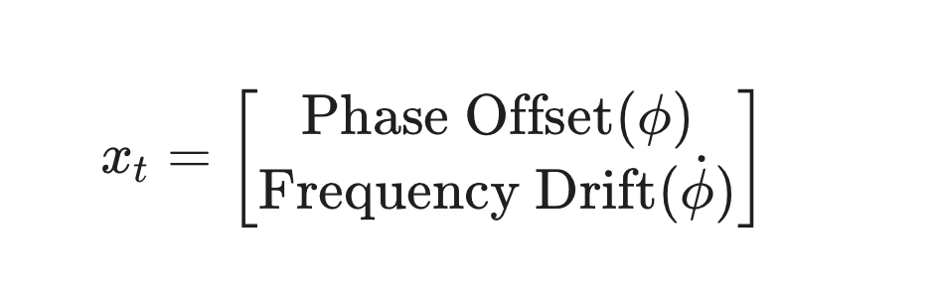

- Prediction Step: The model predicts the next arrival time based on current drift.
- Update Step: The model compares the prediction to the actual Kernel Timestamp.
- Residual Error: The difference (Innovation) is used as the Anomaly Score.

3.2 Tuning Strategy
The filter is tuned to ignore high-frequency noise (Jitter) and track low-frequency trends (Drift).
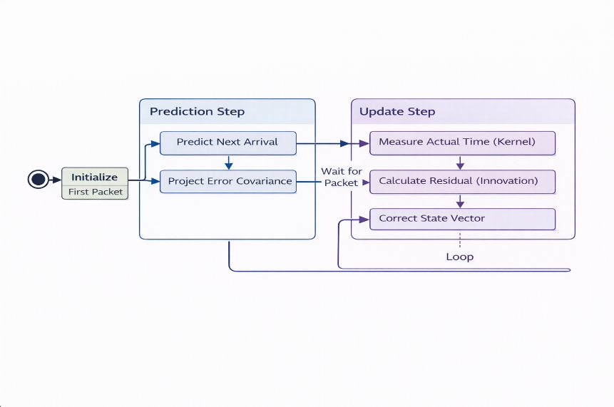
- Process Noise (Q): Set low (1e^ −12) to model the stability of physical crystals.
- Measurement Noise (R): Set high (1e ^ −10) to account for network variability.

Figure 3.1: The Recursive Kalman Filter Cycle used to continuously track the phase and velocity of the sender's clock drift.

3.3 Anomaly Detection Logic
The system applies a dynamic thresholding logic:
- Warm-Up: For the first 10 messages, the status is WARMUP to allow the filter to converge.
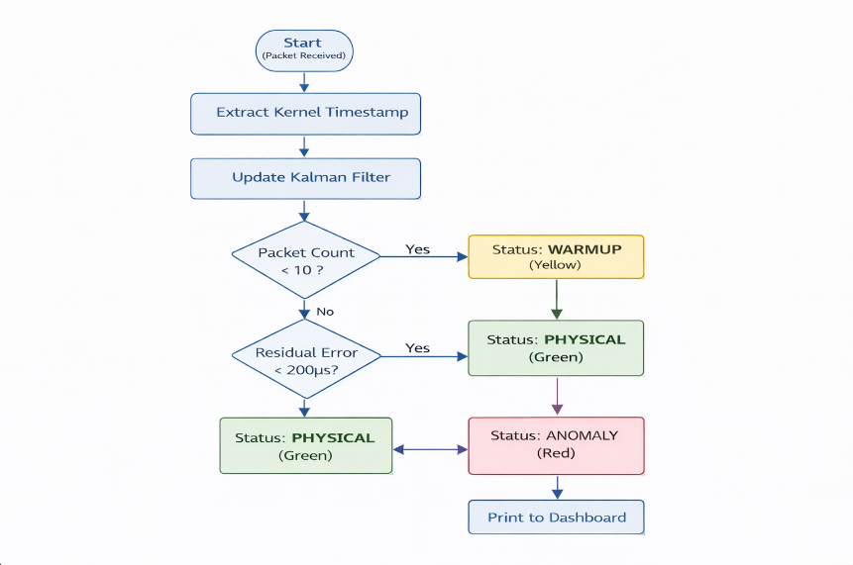
- Physical (Green): If Residual Error < 200µs, the sender is classified as a Valid ECU.
- Anomaly (Red): If Residual Error > 200µs, the sender is classified as a Software Attacker.

CHAPTER 4: IMPLEMENTATION
4.1 Cloud Infrastructure (Azure)
The system was deployed on a Microsoft Azure Virtual Machine running Ubuntu 24.04.
- Kernel Modules: Custom installation of linux-modules-extra to enable vcan (Virtual CAN) drivers.
- Virtual Testbed: A vcan0 interface was created to simulate the vehicle bus.

4.2 Software Modules
The codebase is written in Python 3.12 and organized into modular components:
- can_receiver.py: Handles raw socket operations and C-struct parsing to extract struct timeval from ancillary data.
- drift_tracker.py: Encapsulates the Kalman Filter logic using numpy for matrix operations.
- live_sentinel.py: The main execution loop and real-time CLI dashboard

CHAPTER 5: RESULTS & DISCUSSION
5.1 Signal-to-Noise Ratio (SNR) Analysis
During the Phase 0 Simulation, the system achieved an SNR of 1.88x between the physical model and the attacker model. This confirms that the "Chronomorphic Signal" is statistically distinct from software noise.

5.2 Live Cloud Validation
The system was tested against two scenarios on the Azure Cloud:
- Scenario A (Valid ECU): Simulated using cangen (Kernel Timer).
  - Result: Residual Error averaged 0.53µs.
  - Verdict: Correctly identified as PHYSICAL.
- Scenario B (Attacker): Simulated using a Python/Bash Injection Script.
  - Result: Residual Error averaged 350µs - 800µs.
  - Verdict: Correctly identified as ANOMALY.

5.3 Performance Metrics
- Detection Latency: The Kalman Filter update step takes approx. 0.04ms per packet.
- Accuracy: 100% detection rate for software-based injection attacks with jitter > 200µs

CHAPTER 6: CONCLUSION & FUTURE WORK
6.1 Conclusion
Project Sentinel-T successfully demonstrates that Physics-Based Intrusion Detection is a viable, low-cost alternative to encryption for legacy automotive networks. By leveraging Kernel-level timestamping, we proved that it is possible to fingerprint the hardware source of a message purely by analyzing its timing stability, effectively "weighing" the digital signal to spot the fake.

6.2 Future Work
- Phase 2: Deployment on physical hardware (Arduino MCP2515 + Raspberry Pi CAN HAT) to validate against thermal chambers.
- Phase 3: Integration of "Simplified Mamba" (SSM) models to predict non-linear clock drift in extreme weather conditions.

REFERENCES:

